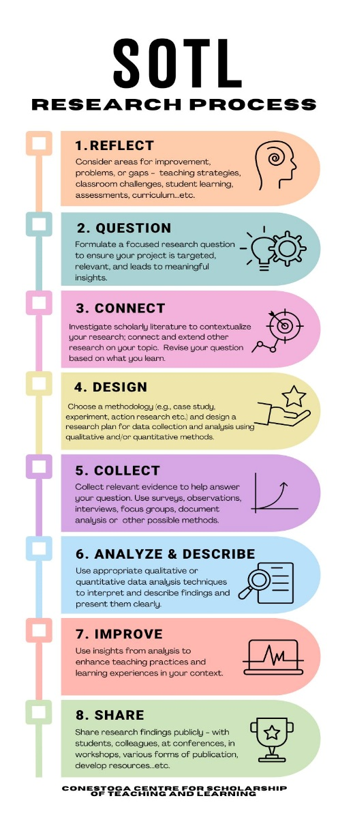Scholarship of Teaching and Learning (SoTL) Project Planning Template

Engaging in SoTL research is a unique opportunity for you to gain insights into your teaching and your students’ learning. Designing a SoTL project involves reflection and planning to ensure you take a systematic approach to the research process.

Your SoTL project can be done individually or in collaboration with others. You are also encouraged to share your findings or discoveries with others on campus or within appropriate scholarly communities as your project may have great benefits to helping others improve teaching and learning in their contexts.

This **project planning template** will help you to think through and plan a systematic and ethical approach to your SoTL project. Please use the **linked resources** throughout this document to support your planning.

**Project Information**

|  |  |
| --- | --- |
| Project Title: | Click here to enter text. |
| Principal Investigator: | Click here to enter text. |
| Status:  (Full-Time/Part-Time/Partial-Load) | Full-Time |
| Program: | Click here to enter text. |
| School: | Click here to enter text. |
| Co-Investigator (if applicable): | Click here to enter text. |
| Co-Investigator (if applicable): | Click here to enter text. |

**Research ethics:** Will your proposed project involve human participants?

Yes  No

If *yes*, the project will require research ethics review and approval before you begin. For further information visit the Conestoga [Research Ethics Board](https://research.conestogac.on.ca/work-with-us/research-ethics) (REB) website. Some of the information you create in this planning template can also be useful to add to your ethics application.

Conestoga also requires researchers to complete a mandatory online tutorial called [CORE-2022](https://www.tcps2core.ca/welcome) which outlines Canada’s Tri-Council Policy on research involving humans. You will be asked to submit a certificate of completion, with your ethics application to Conestoga’s REB.

Resource: [SoTL research ethics - Conestoga Applied Research (conestogac.on.ca)](https://research.conestogac.on.ca/centre-for-scholarship-of-teaching-and-learning/sotl-research-ethics)

Resource: [Ethical Considerations for SoTL Research in Canada](https://taylorinstitute.ucalgary.ca/sites/default/files/22-TAY-SoTL-Ethics-Feb18.pdf)

1. **Reflect on a Topic**

Consider your classroom, instructional practices and identifying areas for improvement. Try to narrow down your topic into one aspect of learning and teaching that could be explored within semester or two. Describe your topic in a few sentences.

*Resource:* [*Identifying a SoTL Topic*](https://stuconestogacon.sharepoint.com/:b:/s/CC_CSoTL/EZ0UvO9tf5RJmarrN8iS67UB-XwbLGIduH6ndoRtWC6WKw?e=7YwgJy)

*Resource:* [*Design a SoTL Research Project – Getting Started*](https://research.conestogac.on.ca/centre-for-scholarship-of-teaching-and-learning/design-a-sotl-project)

|  |
| --- |
|  |

1. **Research Question(s)**

Write a focused research question that accurately captures the aspect of learning and teaching you are exploring in your research project. Remember to keep in mind your project will help you to better understand or improve student learning.

*Resource:* [*Quailties of a good SoTL Research Question*](https://stuconestogacon.sharepoint.com/:b:/s/CC_CSoTL/ET-JPyqKo-xOrr4l_md62dMB5WO5PeVnwtRrVi7rOX62yA?e=8GM4Xq)

*Resource:* [*Taxonomy of Resarch Questions*](https://www.centerforengagedlearning.org/studying-engaged-learning/asking-inquiry-questions/) *(Video)*

*Resource:* [*Question Sentence Starters*](https://stuconestogacon.sharepoint.com/:b:/s/CC_CSoTL/EYVXJjN_OXNCixdzMxtDAfABbxztZS45DrGsUN4eWqzwpA?e=YxQ2G4)

*Resource:* [*Narrow Down a Research Question*](https://stuconestogacon.sharepoint.com/:b:/s/CC_CSoTL/ERyiWGqgO_FJvAZ0o2NNwAsBofOKh-wYr2wAdBmgSLrg-A?e=vqpXK5)

|  |
| --- |
|  |

1. **Connect to Literature**

Provide a rationale and description of the area of research to which your project is connected. This will help to contextualize your project within other related research, including what others have said about the topic/issue already, why it’s important, and help to support your claims about the topic in your teaching and learning context. Use no less than 3-4 key papers to develop this section.

*Note of caution: Using Generative AI can help you in this process; however, it can often provide titles and abstracts for sources that do not exist. Always cross check the papers you find using Google Scholar or the access data bases through the* [*Conestoga Library*](https://library.conestogac.on.ca/)*.*

*Resource:* [*Conestoga Library SoTL Literature Review Resources*](https://lib.conestogac.on.ca/sotl)

*Resource:* [*Disciplne-Specific Journals*](https://guides.library.utoronto.ca/SOTL_journals_databases/Discipline_Specific#:~:text=Discipline%20Specific%20Journals.%20Scholarship%20of%20Teaching%20and%20Learning%20(SoTL)%20A)

*Resource:* [*Purpose of the SoTL Literature Review*](https://stuconestogacon.sharepoint.com/:b:/s/CC_CSoTL/EbykT7crhchFj9mBc8jrfqEBuRt4Sh0CZE_PQ-B7Gm6JYA?e=5ubOmG)

*Resource:* [*A Practical Guide for Reviewing SoTL Literature*](https://journalhosting.ucalgary.ca/index.php/TLI/article/view/75823#:~:text=We%20provide%20a%20practical,%20critical%20guide%20to%20undertaking%20SoTL%20literature)

The table below can help you to organize and analyze this key literature.

|  |
| --- |
| Example: This study will explore …[**describe the problem/topic in your own words, building on ideas from the papers you’ve read]…** Research has shown that… **[Drawing on the papers and the details in the table below]…** My study will address **[describe how your study differs or a gap that you will address in current research]** |

|  |  |  |
| --- | --- | --- |
| **Paper**  (authors, year, title, publication title) | **Describe how the paper relates to your project**  Provide a brief summary (2-3 sentences) of the paper and explain how it informed your research question/design | **Describe how your project differs.**  Will you replicate the study and extend their findings? Address a gap? Use an improved design or additional measurement? Test in a different context? |
|  |  |  |
|  |  |  |
|  |  |  |
| 4. |  |  |

*(Adapted from: http://www.humber.ca/centreforteachingandlearning/)*

1. **Design – Participants**
2. Will students who you are currently teaching be participants in your research?
3. **Yes**

My research is focused solely on examination of students’ coursework. I will seek consent from students to examine their work for the purpose of research. Students will have the option to participate, and their decision will not affect their standing in the course. I’ll also notify students that only anonymized data may be used in future publications or presentations. *(REB approval required if for research; REB Approval not required if data used for course improvement purposes only)*

My research involves minor contributions beyond regular coursework (e.g., a short survey). I will have a third-party who is not involved in my course obtain informed consent from students. Students will be informed that their participation is voluntary, that they may withdraw at any time, and that their decision about whether to take part in the project will not impact their standing in the course. *(REB approval required if for research; REB Approval not required if data used for course improvement purposes only)*

Other: Please explain student participation and include how you will avoid any conflicts of interest.

|  |
| --- |
|  |

*Resource:* [*Teachers as SoTL Researchers: Navigating Dual Roles to put Student Learning First*](https://tlconestoga.ca/teachers-as-sotl-researchers/#:~:text=In%20essence,%20putting%20student%20learning%20first%20in%20SoTL%20research%20is)

1. **No**

Describe who will participate in your research, approximately how many participants will be involved, and the level of commitment of their participation (how they will participate and how much time). Describe the steps you will take to invite participants to take part in your study.

|  |
| --- |
|  |

1. **Design - Data collection methods**

Describe how you will collect data/evidence to help you to answer your research question. Which quantitative or qualitative methods will you use? Or a mix of both? Explain how the method(s) will help you to answer your research question*.* **\* Provide enough information for someone else to be able to replicate your study.**

*Resource:* [*Tips for Identifying Evidence in SoTL*](https://stuconestogacon.sharepoint.com/:b:/s/CC_CSoTL/EbK4ZdjidQ5KvxWJr1jbtVIBoSMhecYyFEBuC9zAJQcedg?e=ve7u6m)

*Resource:* [*Gathering Evidence: Making Student Learning Visible*](https://my.vanderbilt.edu/sotl/doing-sotl/gathering-evidence/#:~:text=While%20a%20teacher%E2%80%99s%20reflections,%20the%20reflections%20of%20his%20or%20her)

|  |
| --- |
|  |

1. **Collect Evidence**

At what points in the research process will you collect data (e.g. end of semester, start of semester, throughout the semester)? If using multiple methods, outline the timeline for each method you plan to use.

|  |
| --- |
|  |

1. **Analyze & Describe Evidence**

Describe how you plan to analyze your data/evidence.

|  |
| --- |
|  |

*Resource:* [*Tips for Analyzing and Describing Data/Evidence*](https://stuconestogacon.sharepoint.com/:b:/s/CC_CSoTL/EYvlPkYIzWJNiAd2HkFPktABsxDA8GHAo0R4pQp1uKkGdA?e=XtcmxC)

1. **Improve - Expected Outcomes**

Describe the potential benefits and/or outcomes of your proposed project. How will your project ultimately help to better understand or improve student learning?

|  |
| --- |
|  |

1. **Share**

Describe how you plan to share what you learn from this project with relevant audiences at Conestoga and beyond.

|  |
| --- |
|  |

*Resource:* [*Going Public with SoTL*](https://www.youtube.com/watch?v=namehdJxRIM)

*Resource:* [*Select SoTL Journals*](https://lib.conestogac.on.ca/c.php?g=740979&p=5349810)

1. **Student Involvement**

SoTL is strengthened by including all relevant perspectives, particularly those of learners who are at the center of teaching and learning experiences. Describe the roles of any students who will be involved in supporting the project. Describe the knowledge and experience gained by students including opportunities for enriched training experiences to develop relevant research skills, as well as professional skills such as leadership. communication, and collaboration. How might you recognize their contributions? If students are not involved, provide an appropriate justification.

|  |
| --- |
|  |

1. **Equity, Diversity and Inclusion**

Describe one specific action you will take in support of EDI to create an inclusive research environment and/or in the design of your research methodology.

|  |
| --- |
|  |

1. **Work Plan/ Activity Schedule**

Note: For CNERG Grants, plan for one semester (14-15 weeks). For all other projects, your plan may extend up to 1 year.

|  |  |  |  |
| --- | --- | --- | --- |
| **Activity** | **Description** | **Anticipated Start Date** | **Anticipated Completion Date** |
|  |  |  |  |
|  |  |  |  |
|  |  |  |  |
|  |  |  |  |

1. **Project Budget and Justification (Only needed if applying for CNERG)**

Download and complete the budget table – available through Conestoga’s Researchers’ Portal.